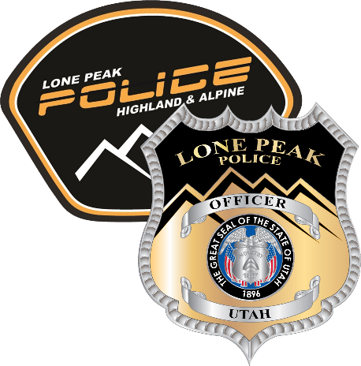

**Employment Opportunity**

**Lone Peak Police Department**

Position: Police Officer

Department: Lone Peak Police Department

Pay Range: $27.47 to $45.85 per hour – based on qualifications/experience

Starting Wage: $27.47 per hour

Status: Full-time

Closing Date: Open until filled

**Position Summary: Police Officer**

This role requires the officer to respond to emergency situations, investigate crimes, gather evidence, and maintain a visible presence to deter criminal activity. Police officers uphold legal and ethical standards, ensuring the safety and security of the public while promoting positive relationships with the community. This role involves working in various environments, including patrolling neighborhoods, responding to incidents, conducting traffic stops, and collaborating with other agencies as necessary.

**Key Responsibilities:**

* Enforce local, state, and federal laws and ordinances.
* Respond to emergency calls and service requests, including accidents, crimes, disturbances, and emergencies.
* Conduct preliminary investigations at crime scenes, gather evidence, and interview witnesses and suspects.
* Write clear and concise reports detailing activities, investigations, and arrests.
* Patrol assigned areas to maintain law and order and deter criminal activity.
* Engage with community members to build trust, provide education, and promote safety awareness.
* Make arrests, issue citations, and testify in court as necessary.
* Administer first aid and CPR when needed and assist emergency medical services as required.
* Follow department procedures for the use of force and ensure compliance with legal standards.
* Attend training sessions, workshops, and briefings to stay current with law enforcement practices, legal updates, and department policies.

**Qualifications:**

* High school diploma or equivalent (GED); some positions may require additional education or training.
* Valid Utah state driver’s license with a good driving record, deemed insurable and able to operate city-owned vehicles.
* Possession of the Peace Officer Certification from Utah Peace Officer Standards and Training (POST) is preferred.
* Must acquire and maintain certification with the Bureau of Criminal Identification.
* Must acquire and maintain certifications in the use of firearms, less-lethal devices, CPR, and all other related law enforcement tools and applications.
* Strong communication, problem-solving, and interpersonal skills.
* Ability to remain calm and composed in high-pressure situations.
* Knowledge of law enforcement procedures, criminal law, and community safety.
* Physical fitness to perform duties and manage stressful situations.

**Benefits:**

* Health Insurance: City pays 100% of premium, HSA
* Up to 5% 401K Match
* URS Retirement Plan
* Dental, Life, and Vision Insurance
* Vacation, Holiday, and Sick Leave with longevity increases
* Equipment and Uniform Allowance
* Take-home vehicle
* Onsite Gym: Policy allows exercise during shift
* Paid Parental Leave
* Training and growth opportunities
* City-provided cell phone

**How to Apply:**

Please apply at: https://lonepeakpolice.com/employment/

Questions? Please call us at (801) 756-9800